**Assignment 1 – Data Measurement**

**1. Science Phenomenon**

**Calculate how long it takes for ice to melt in different mediums.**

Amount of time it takes for a 30 g ice cube to melt in various media and note the result.

**Procedure:**

Room Temperature: 68°F

Weight of Ice Cube: 30 grams for each medium

Different Mediums chosen: Vegetable Oil, Hot Water, No Medium, Normal Water, Salt Water, Cool Water

* Take a stopwatch or download a timer application in your phone, 6 bowls, 6 ice cubes, and 6 cups of the above-mentioned mediums.
* Pour the five mediums into five separate bowls leaving one bowl empty.
* Place the ice cubes into the six bowls and start the stopwatch.
* Hit the ‘Lap’ button on the stopwatch every time an ice cube in one of the six bowls melts completely.
* Note down the time against each medium.

**Data Points:**

**Data Visualization:**

**Color coded data table:**

**Insights:**

1. From the graph, we can infer that ice took the maximum amount of time (50.37 minutes) to melt when there was no medium.
2. Looking at the color coded data table, we see that the change in grams/min is highest in hot water (17.41 grams/minute).
3. From the color coded table, we see that the average change in grams/minute of the ice cube is 5.79. Such a high value infers that Hot Water might be an outlier.
4. From the data table, we can infer that ice took the least time to melt in Hot Water (1.72 minutes), this can be observed in the second reading.

**2. Business Phenomenon**

**Measure the number of fruits sold in intervals of 30 minutes**

Record the number of fruits sold every 30 minutes in a supermarket. Data is classified based on the specific fruit.

**Procedure:**

Fruits: Strawberries, Oranges and Lemons

Observation Start & End Time: 4:00 PM to 7:00 PM

* Note down every transaction of fruit sold and name of the fruit.
* Count the total number of fruits sold at the end of the 30th minute and record it against each fruit.
* **A picture containing text, indoor, shop

  Description automatically generated**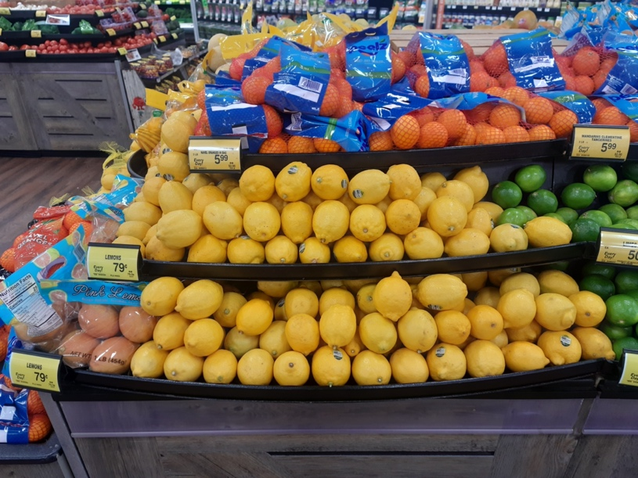A picture containing text, oranges, fruit, variety

  Description automatically generatedRepeat the process for the six intervals.

**Data Points:**

**Data Visualization:**

**Color coded data table:**

**Insights:**

1. Comparing the three fruits in the data table, we observe that the fruit that was sold the most between 4:00 PM and 7:00 PM is Orange (27).
2. From the graph, considering all intervals, we infer that Strawberries and Lemons were sold the most in the 4:00 - 4:30 interval and 4:30 - 5:00 respectively. while oranges were sold the most in the 4:00 - 4:30 interval.
3. From the color coded table, we see that on an average, Oranges are sold the most per interval while Strawberries are sold the least.

**3. General Observation Phenomenon**

**Record the number of cars entering & exiting the community gate every 30 minutes**

**Procedure:**

Observation Start & End Time: 8:00 AM to 11:00 AM

* Note down every car entering and exiting the apartment.
* Count and record the total number of cars that entered and exited at the end of the 30th minute.
* Repeat the process for the six intervals.

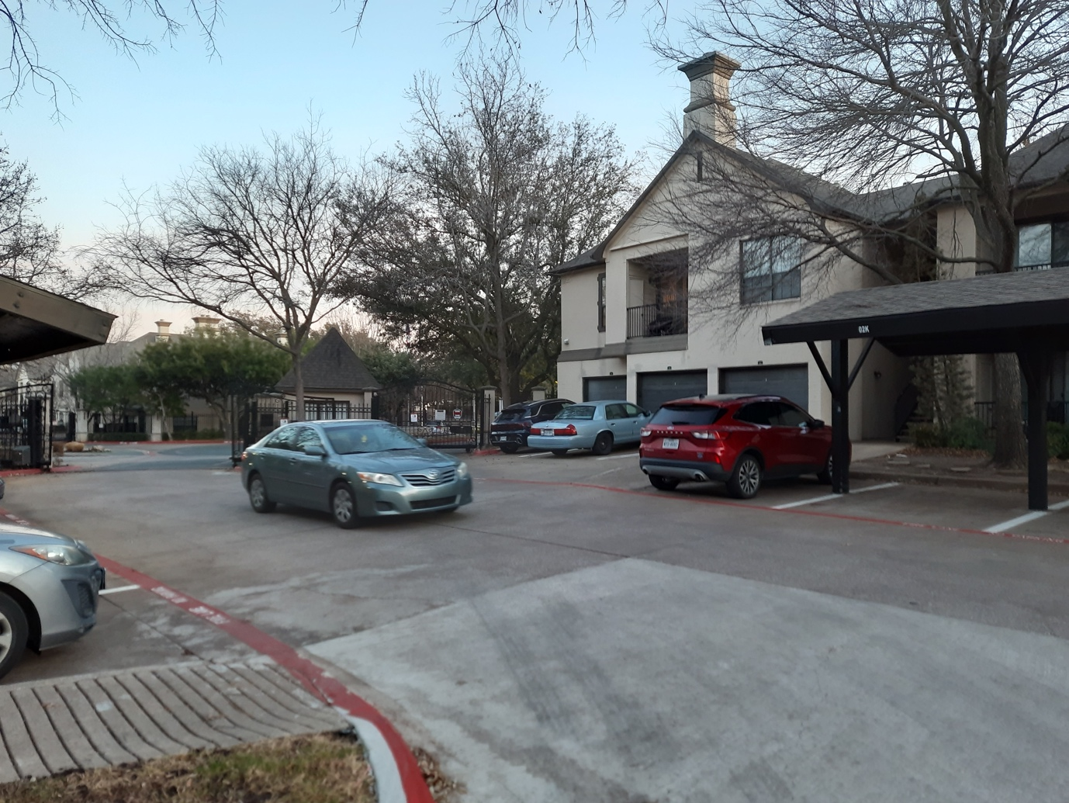

**Data Points:**

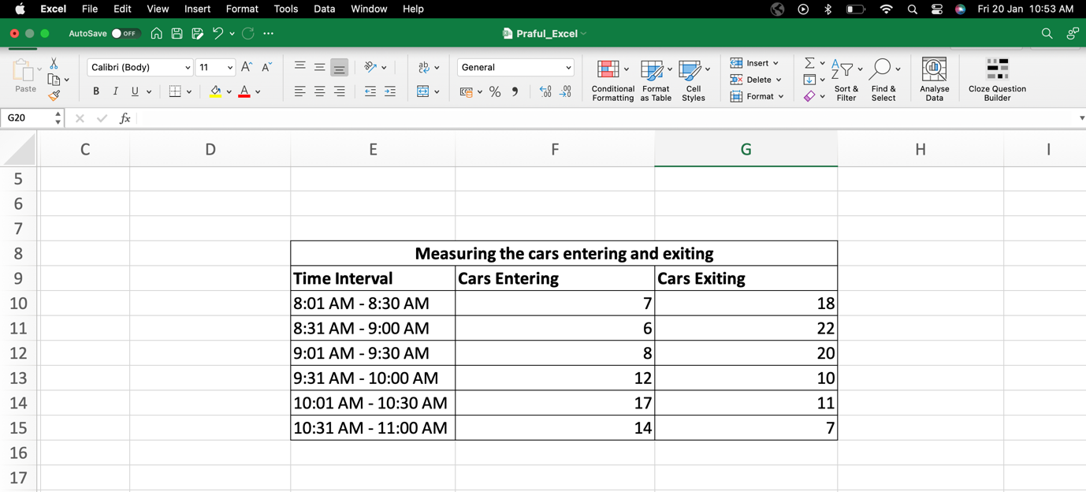

**Data Visualization:**

**Color coded data table:**

**Insights:**

1. From the data table, we see that during the 8:31 AM to 9 AM interval maximum number of cars exited the community where as in the 10:01 AM to 10:30 AM interval maximum cars entered.
2. From the graph, we infer that the least number of cars entered during the 8:31 AM to 9:00 AM interval while the least number of cars exited during the 10:31 AM to 11:00 AM interval.
3. From the color coded data table, we notice that the percentage cars exiting exceeded percentage cars entering in the first three time intervals and vice versa in the last three readings.